

**CSE370 : Database Systems**

**Project Report**

**Project Title : Money Transaction System**

| **Group No: 05, CSE370 Lab Section: 13, Spring 2024** | | |
| --- | --- | --- |
| **ID** | **Name** | **Contribution** |
| 22301061 | Faiaz Abrar Zaman Pronoy | Login, Signup, Logout, Check Balance, Pay Bill, Education Fee, History, Add Money |
| 21301474 | Jahirul Islam Zishan | Reset Password, Send Money, Mobile Recharge, Notifications,  Support |
| 21301298 | Md. Shihab Sarar | Cash In, Cash Out From Agent |
| 21301581 | Nafiz Ahmed Rhythm | Makes Payment,Admin(support, user, solved support,login, logout),Currency Converter |
|  |  |  |

CSE370_LabSection13_GroupNo5_22301061_21301474_21301298_21301581.pdf

**Table of Contents**

| **Section**  **No** | **Content** | **Page No** |
| --- | --- | --- |
| 1 | Introduction | 3 |
| 2 | Project Features | 4 |
| 3 | ER/EER Diagram | 4 |
| 4 | Schema Diagram | 5 |
| 5 | Frontend Development | 6-15 |
| 6 | Backend Development | 16-35 |
| 7 | Source Code Repository | 36 |
| 8 | Conclusion | 36 |
| 9 | References | 37 |

**Introduction**

In today's globalized economy, the need for efficient and secure money transaction systems is more critical than ever. As people increasingly engage in financial activities online, from paying bills to sending money, the demand for a reliable and easy-to-use platform for conducting these transactions is undeniable. This project introduces "TakaLagbe," a comprehensive money transaction system designed to meet these needs, making the process of transferring funds seamless for all users involved.

The core of "TakaLagbe" is built on a combination of HTML, PHP, and MySQL. PHP plays a pivotal role in connecting to the database and handling SQL queries to process transactions securely and efficiently. The front-end utilizes HTML to present data in a user-friendly and aesthetically pleasing manner, enhancing the overall user experience.

The development of the "TakaLagbe" Money Transaction System was guided by the goal of optimizing user interactions and ensuring robust data management and security. This system not only allows users to conduct transactions but also provides a real-time view of their financial activities. Features such as an intuitive search bar let users easily navigate their transaction history. Additionally, for convenience, there is a comprehensive dashboard displaying all transaction activities, allowing users to manage their finances efficiently.

**Enhancing User Experience:** "TakaLagbe" leverages HTML and PHP to minimize page loading times, ensuring a swift user experience. The system includes features like instant transaction processing, which allows users to send and receive money without delays. A well-organized navigation bar and clear, actionable buttons streamline the transaction process, making it straightforward even for first-time users.

**Data Management and Security:** To ensure the integrity and security of transactions, "TakaLagbe" features separate login panels for individual users and administrators. Each login is protected by robust password security measures. If there is a mismatch in the credentials, the system promptly alerts the user with an 'Invalid Username or Password' message. Furthermore, the system employs real-time data retrieval using PHP and SQL, ensuring that users can trust the accuracy of their transaction records. Additional security measures, such as options to update user information and passwords, further fortify the system's defenses against unauthorized access.

**Project Features**

- Login - Signup - Logout - Reset Password

- Check Balance

- Send Money

- Cash In

- Cash Out

- Mobile Recharge

- Pay Bill (Gas, Water, Internet, Electricity)

- Education Fee

- Payment to Merchant

- Transaction History

- Currency Converter

- Notifications

- Add Money

- Admin dashboard

- Admin user info, All payment info, Registered info

- Supports

**ER/EER Diagram**

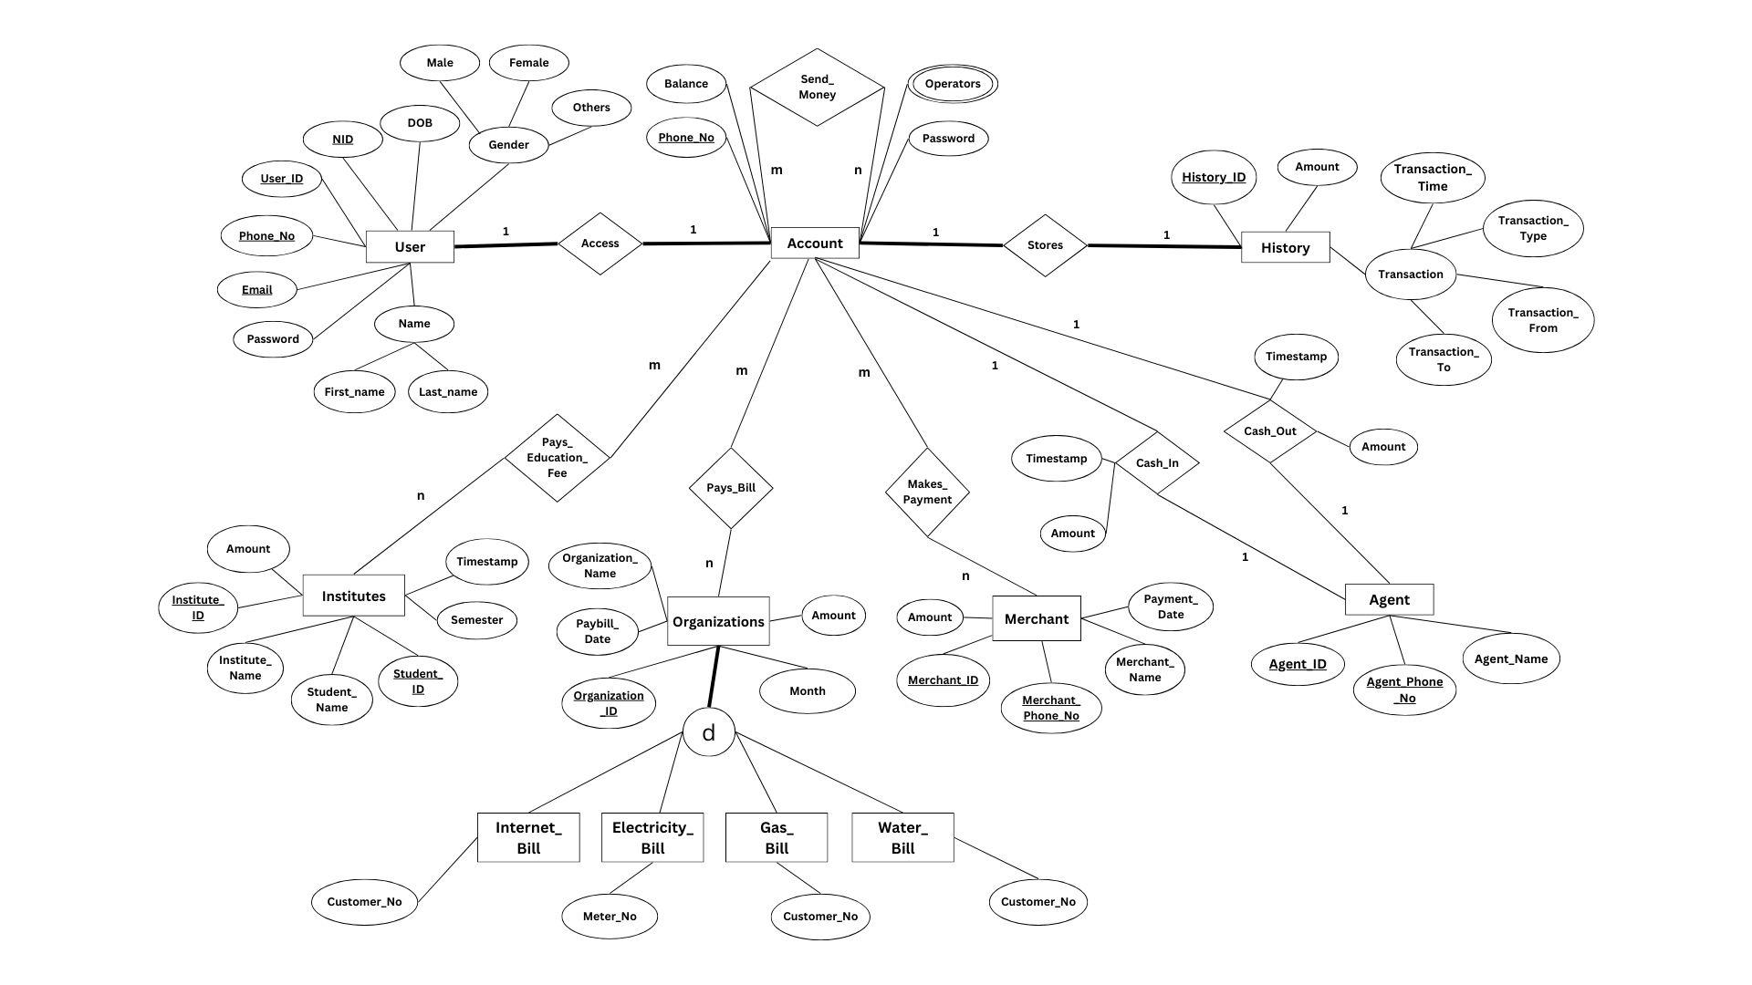

**Schema Diagram**

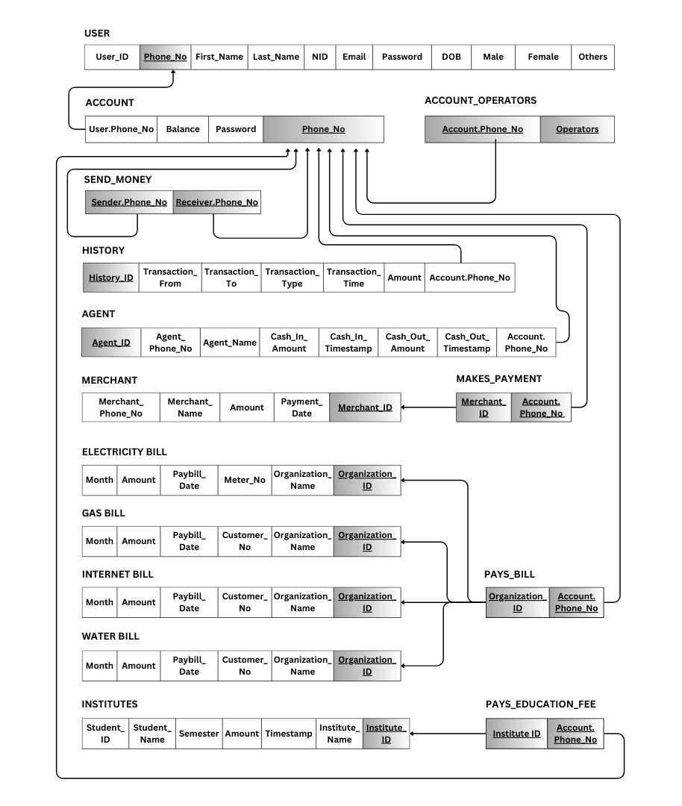

**Frontend Development**

This is a 3 layered project. The first layer develops the structure of our website, the second layer develops the enchantress of our project and the third layer contains all the calculations and logic based on our features’ needs. Here, the first 2 layers are the parts of frontend development. We used HTML(Hypertext Markup Language) and CSS(Cascading style sheets) for frontend development. We used codes from Bootstrap and modified those based on our needs. Through frontend development, we created a signup page, login page, about us page, pay bill page, mobile recharge page, cash-in page, send money page, check balance page etc.

*Contribution of ID : 22301061, Name : FAIAZ ABRAR ZAMAN PRONOY*

*-> Login, Signup, Logout, Check Balance, Pay Bill, Education Fee, History, Add Money*

Login :

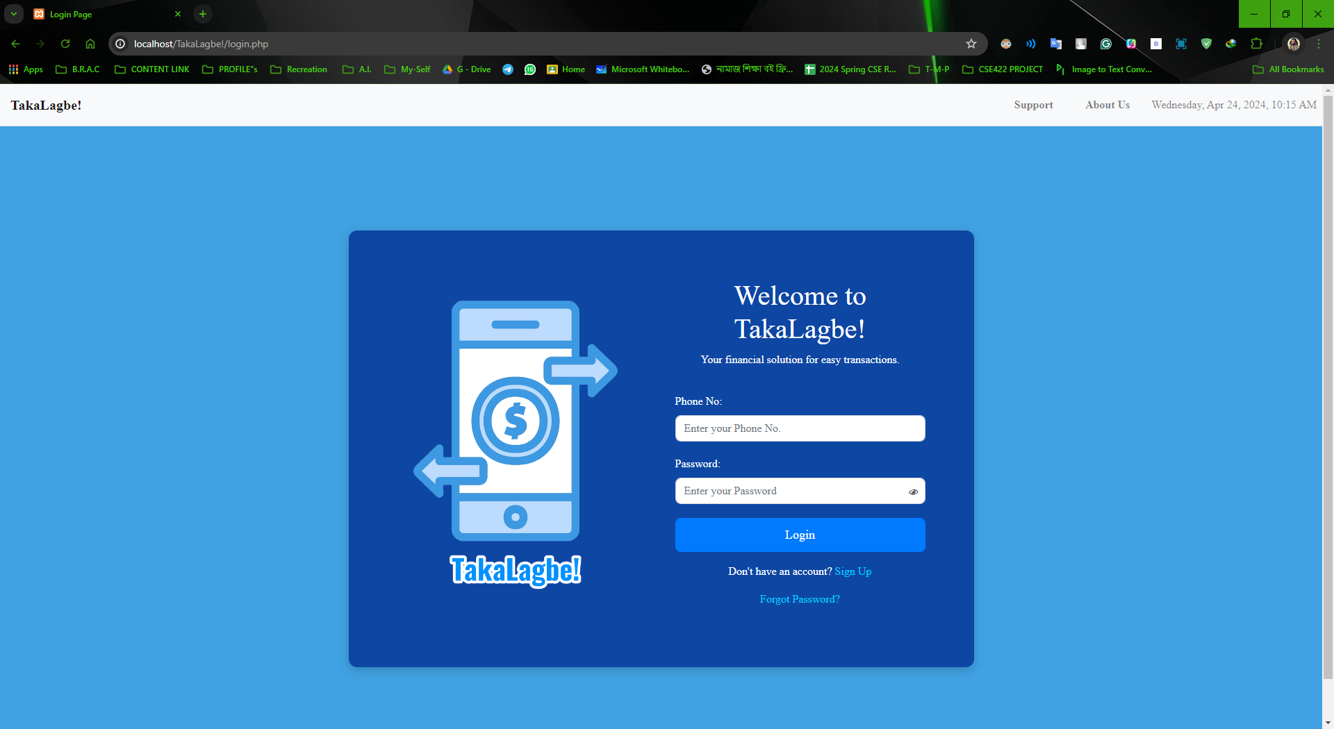

**Logout :**

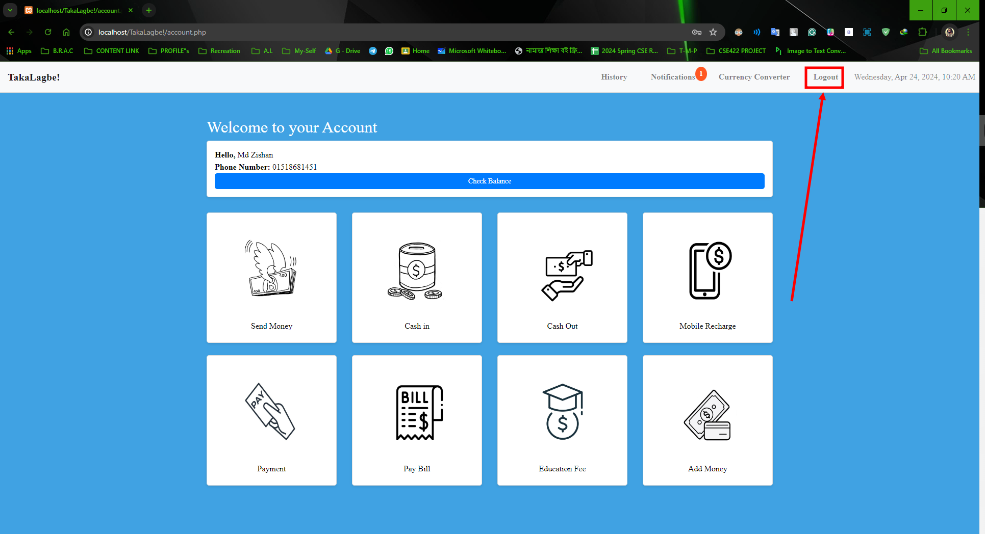

Check Balance:

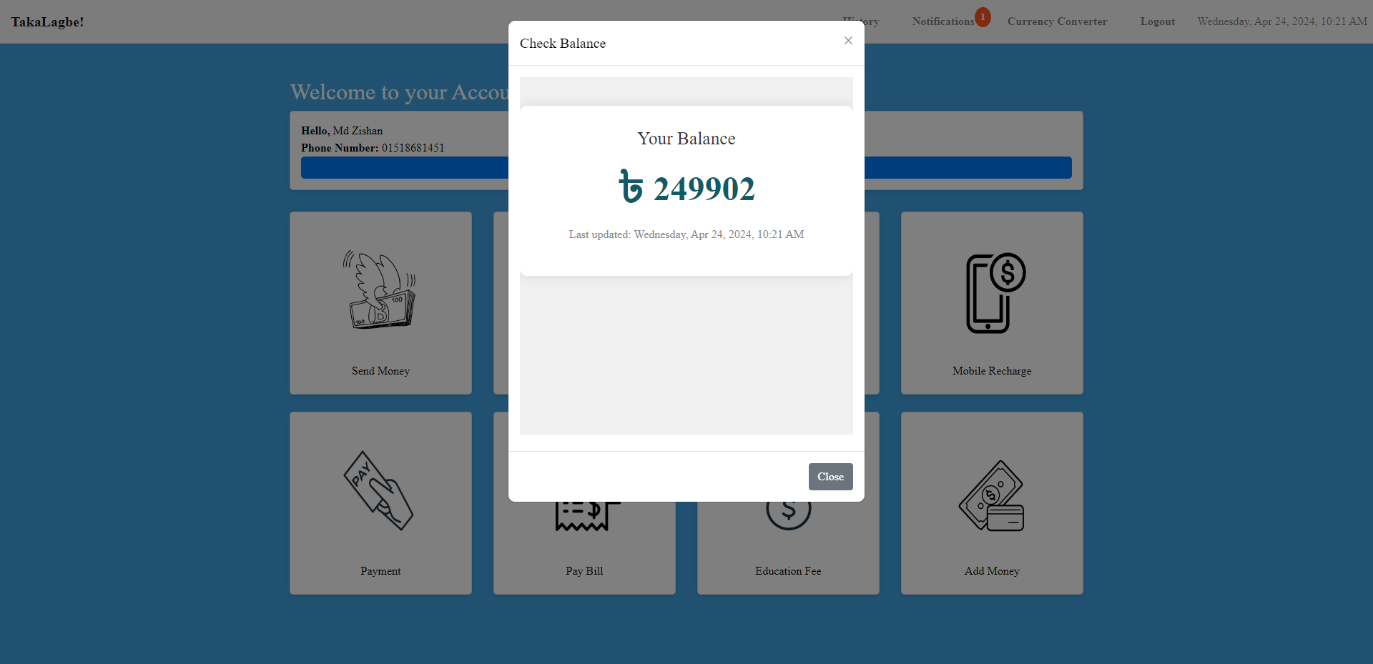

Pay Bill:

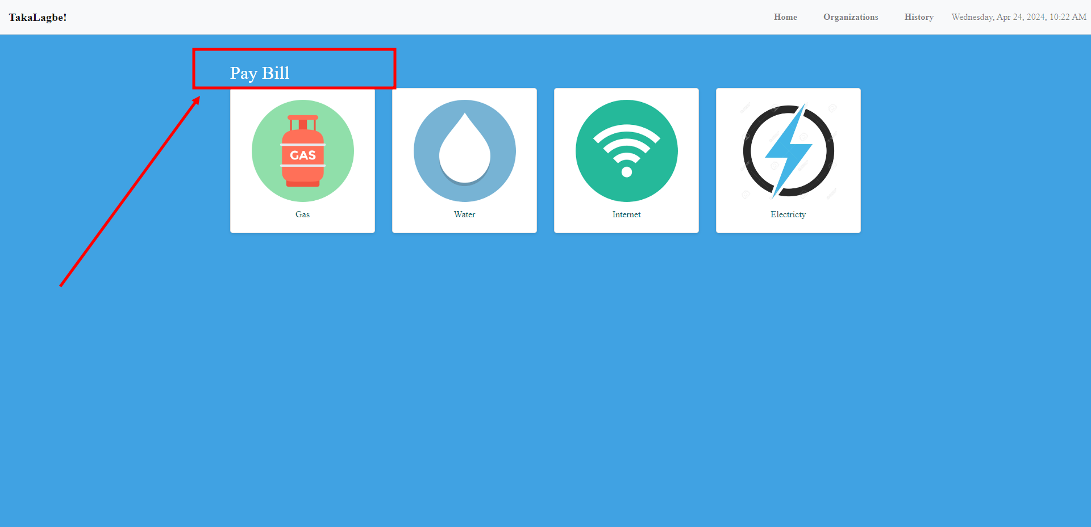

**Education fee:**

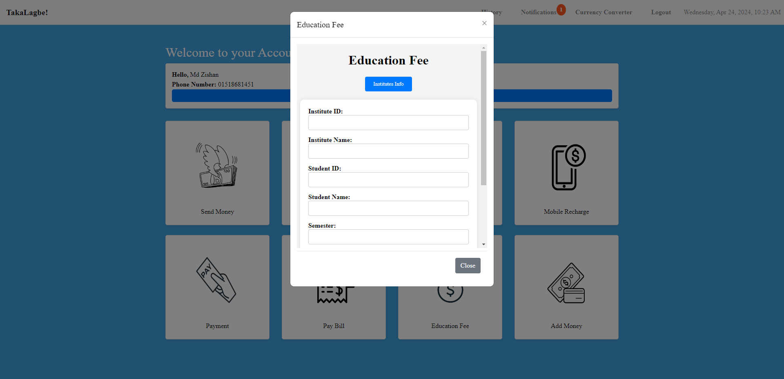

**Add Money:**

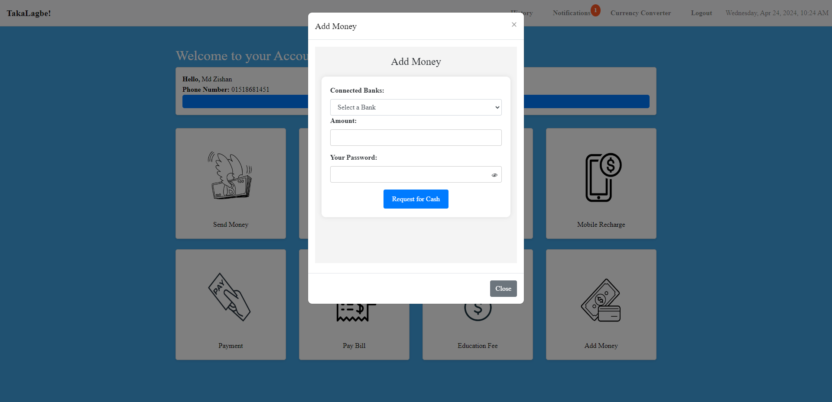

**Contribution of ID : 21301298, Name : Md. Shihab Sarar**

**->**Cash In, Cash Out From Agent

Cash in :

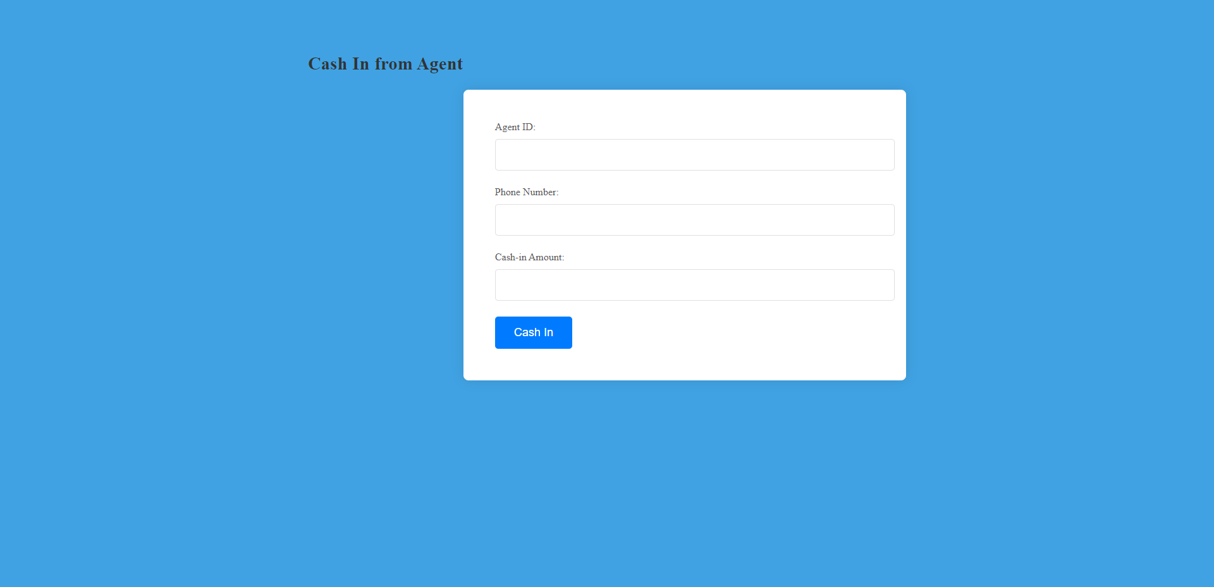

**Cash Out :**

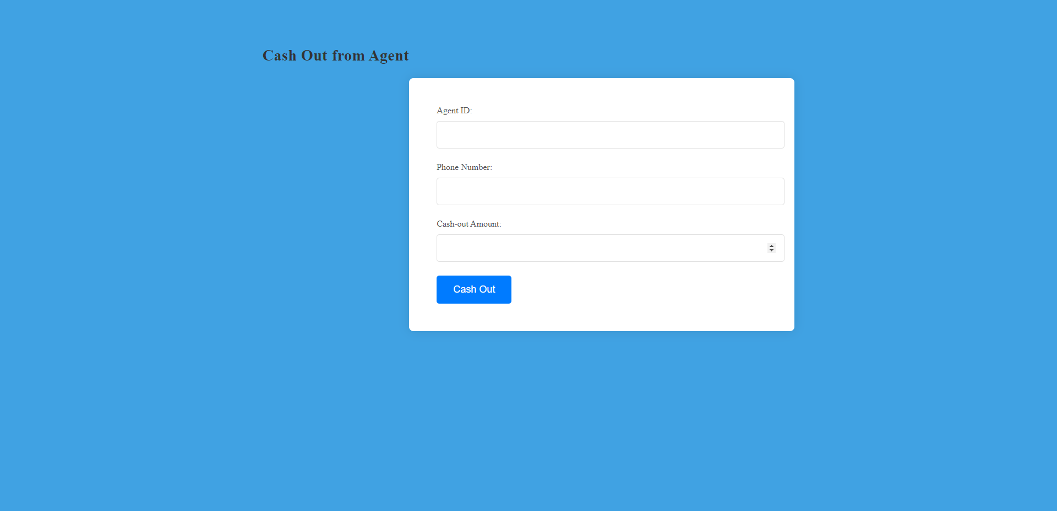

Contribution of ID: 21301581 , Name: Nafiz Ahmed Rhythm

-> Makes Payment,Admin(support, user, solved support,login, logout),Currency Converter

**Makes Payment :**

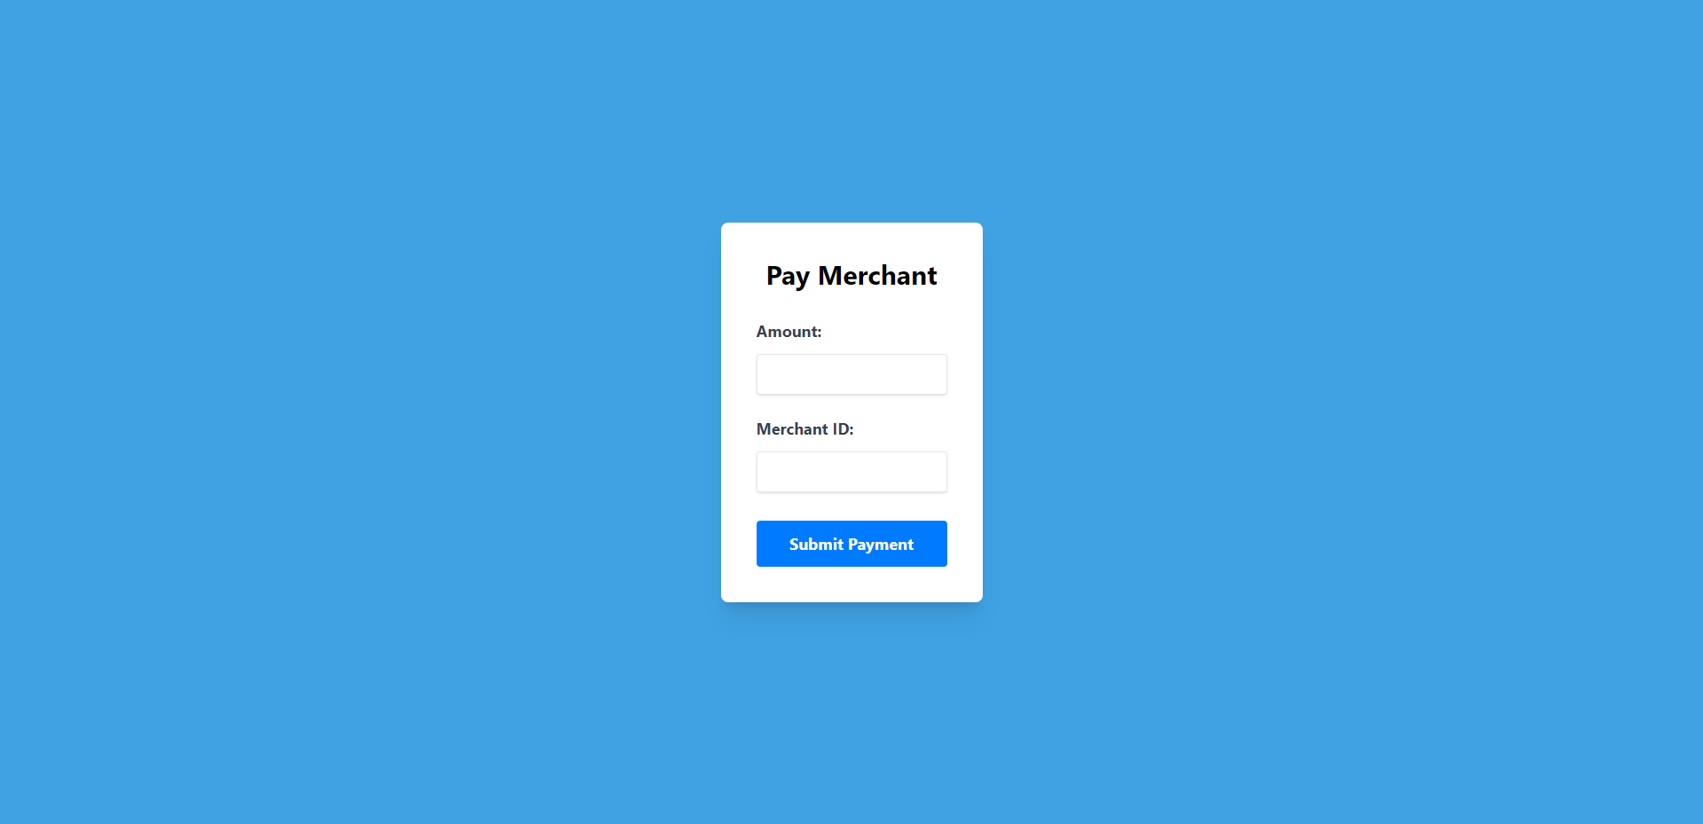

**Currency converter:**

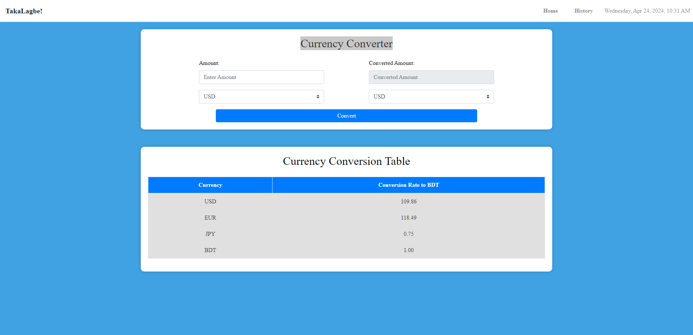

**Admin:**

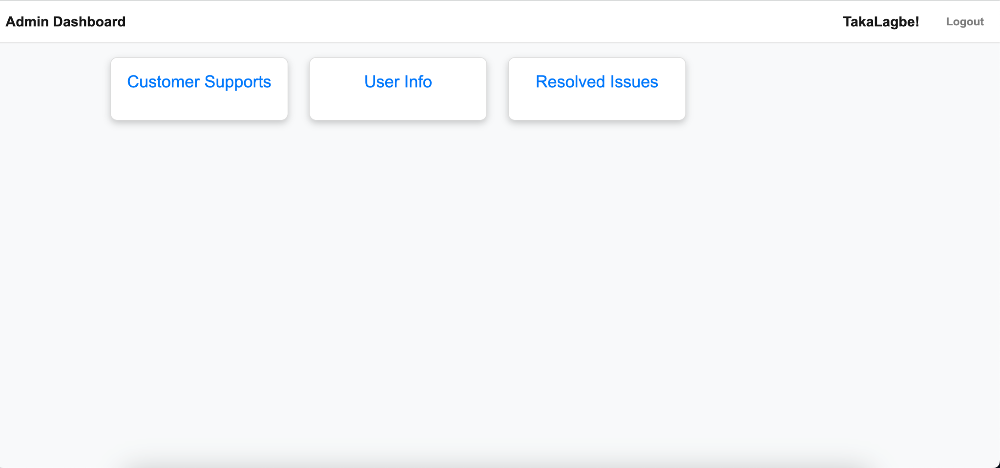

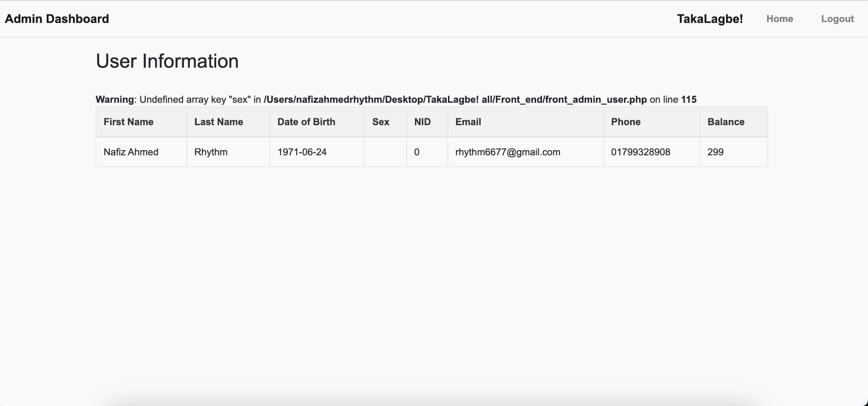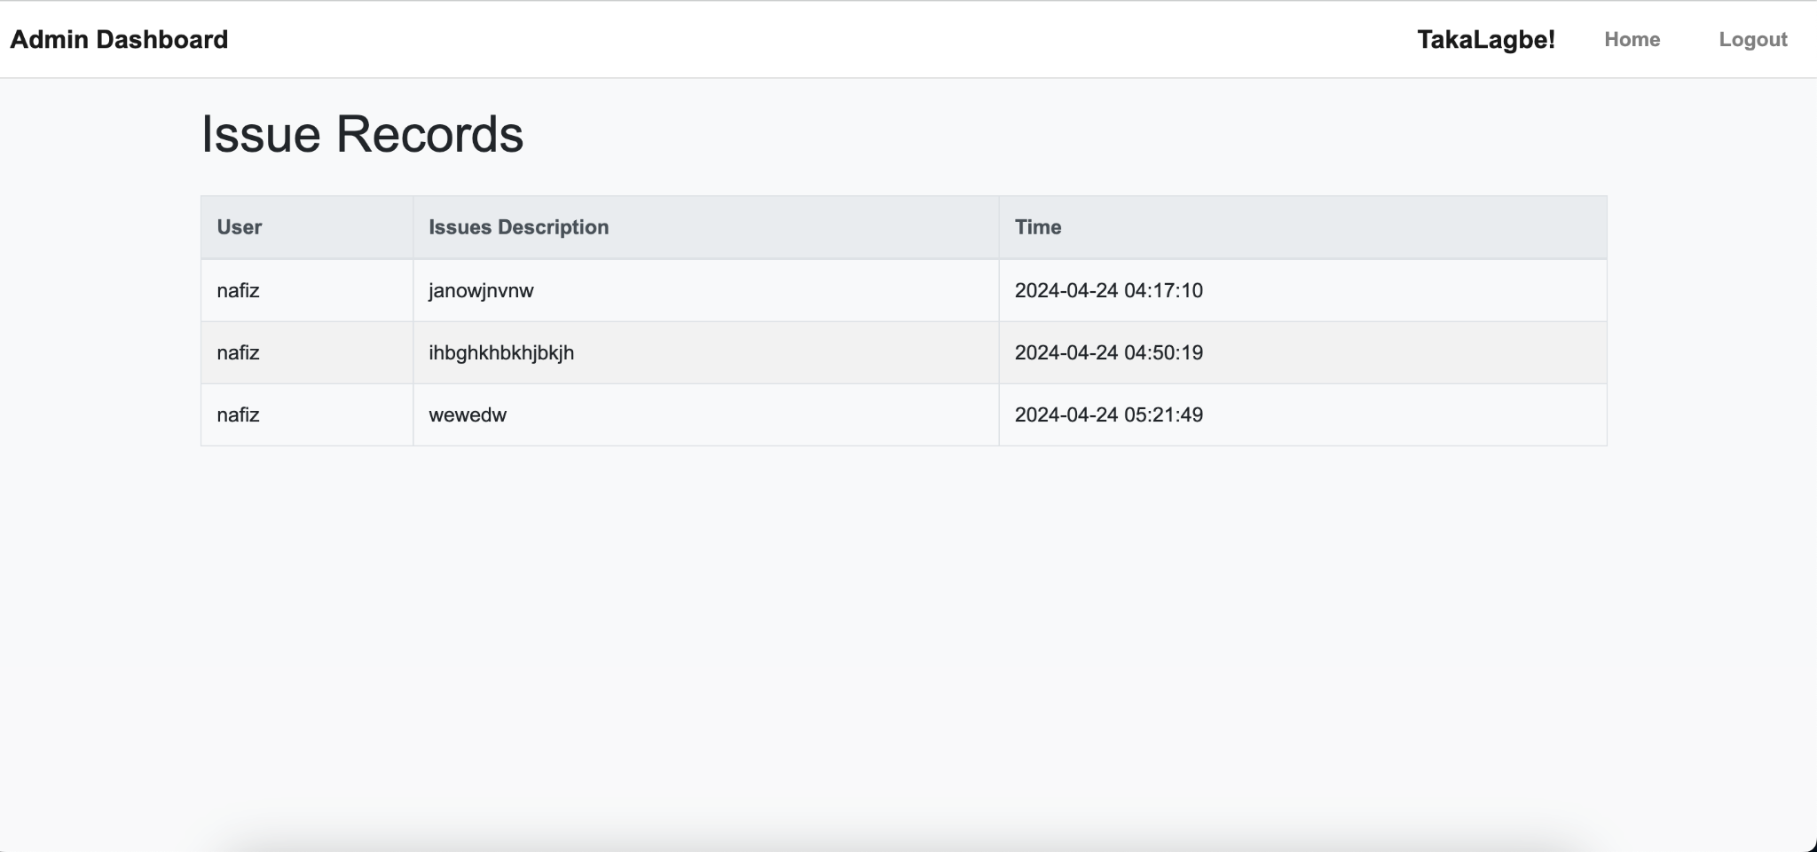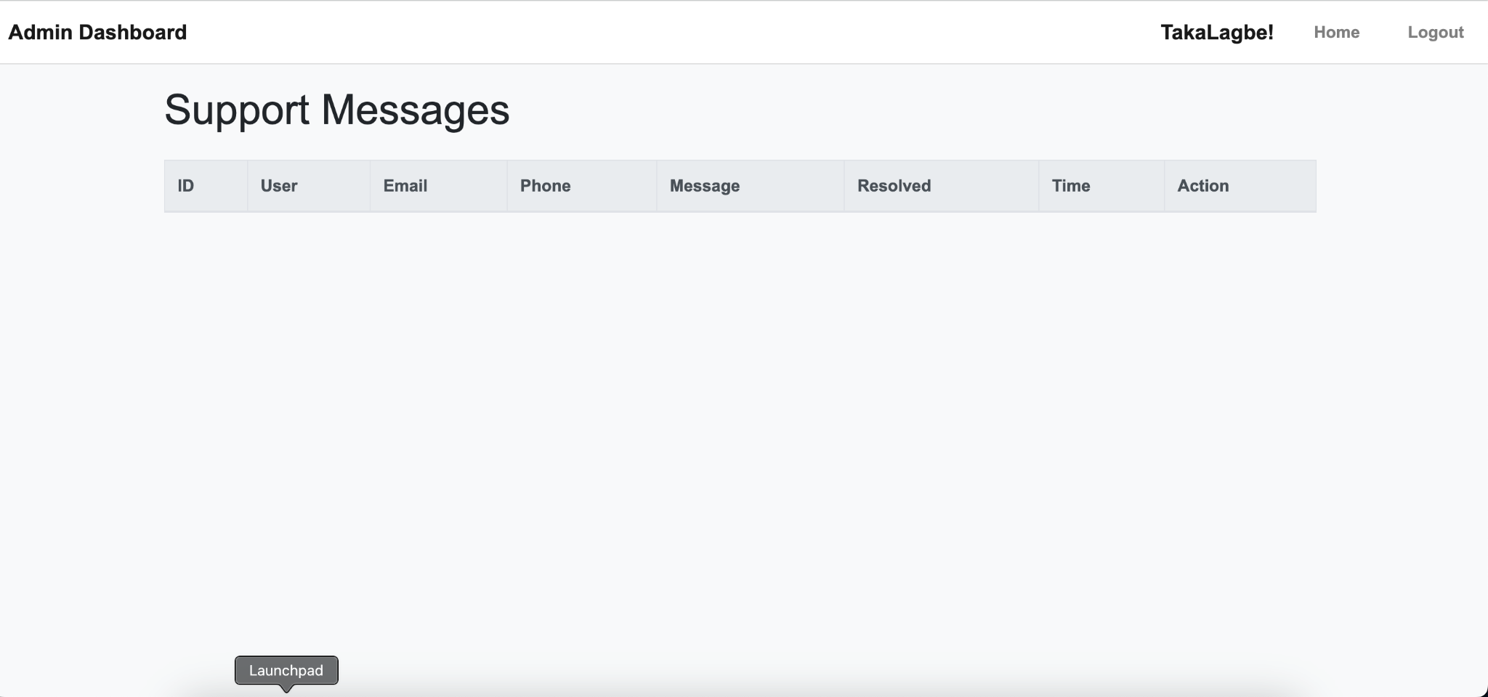

*Contribution of ID : 21301474 , Name : MD JAHIRUL ISLAM ZISHAN*

-> Reset Password, Send Money, Mobile Recharge, Notifications, Support

**Reset Password:**

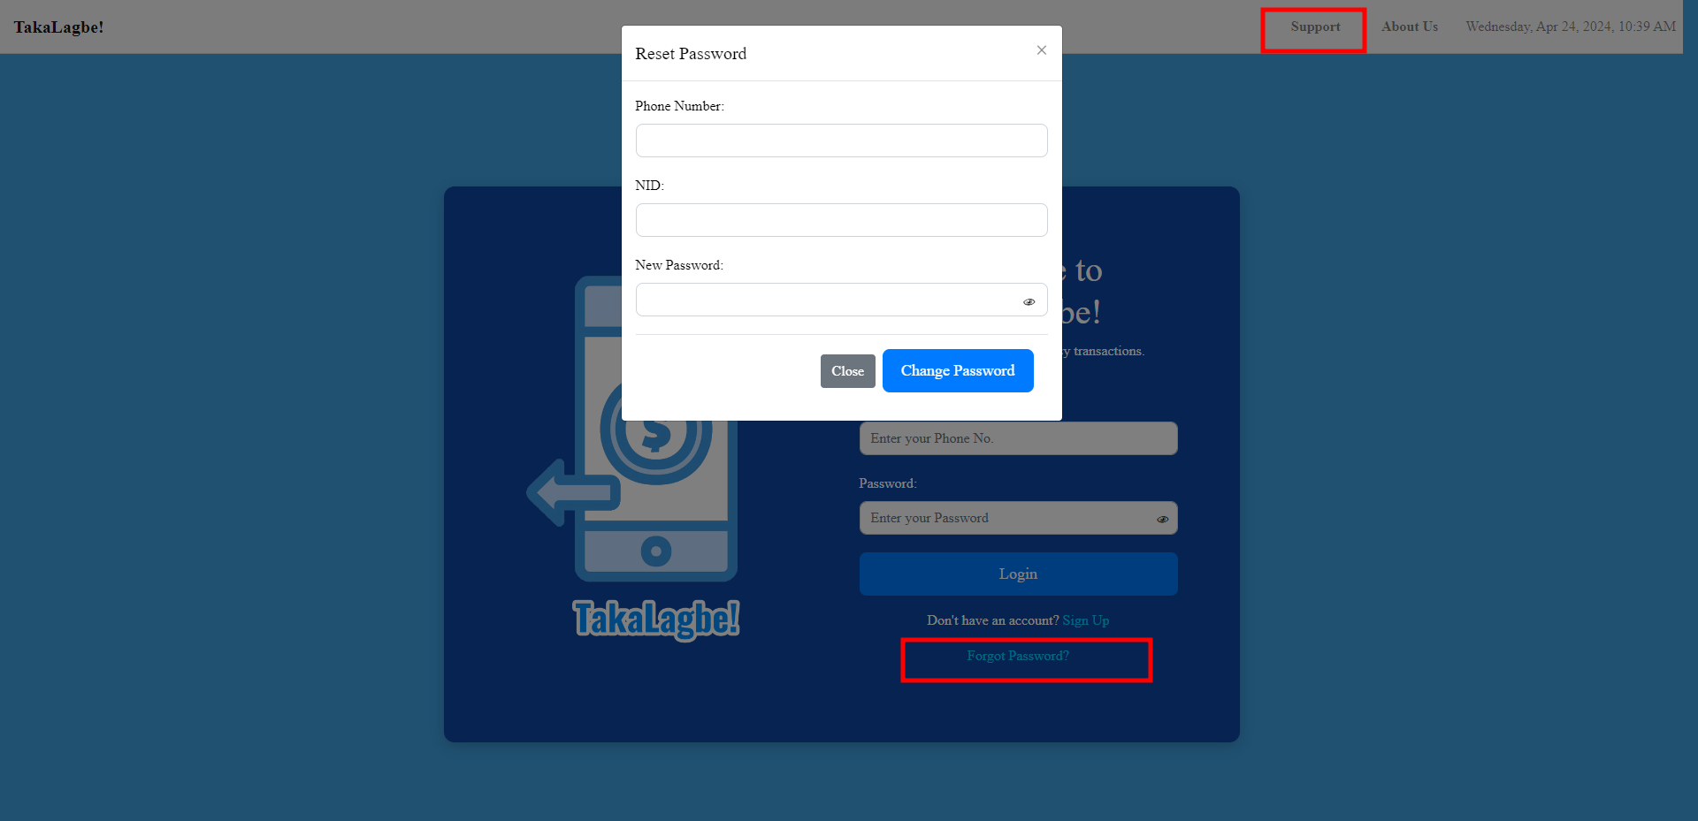

**Send Money:**

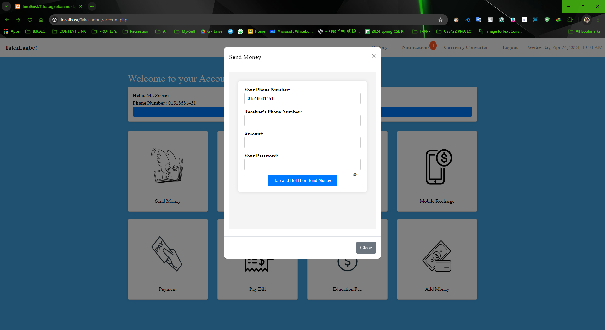

**Mobile Recharge:**

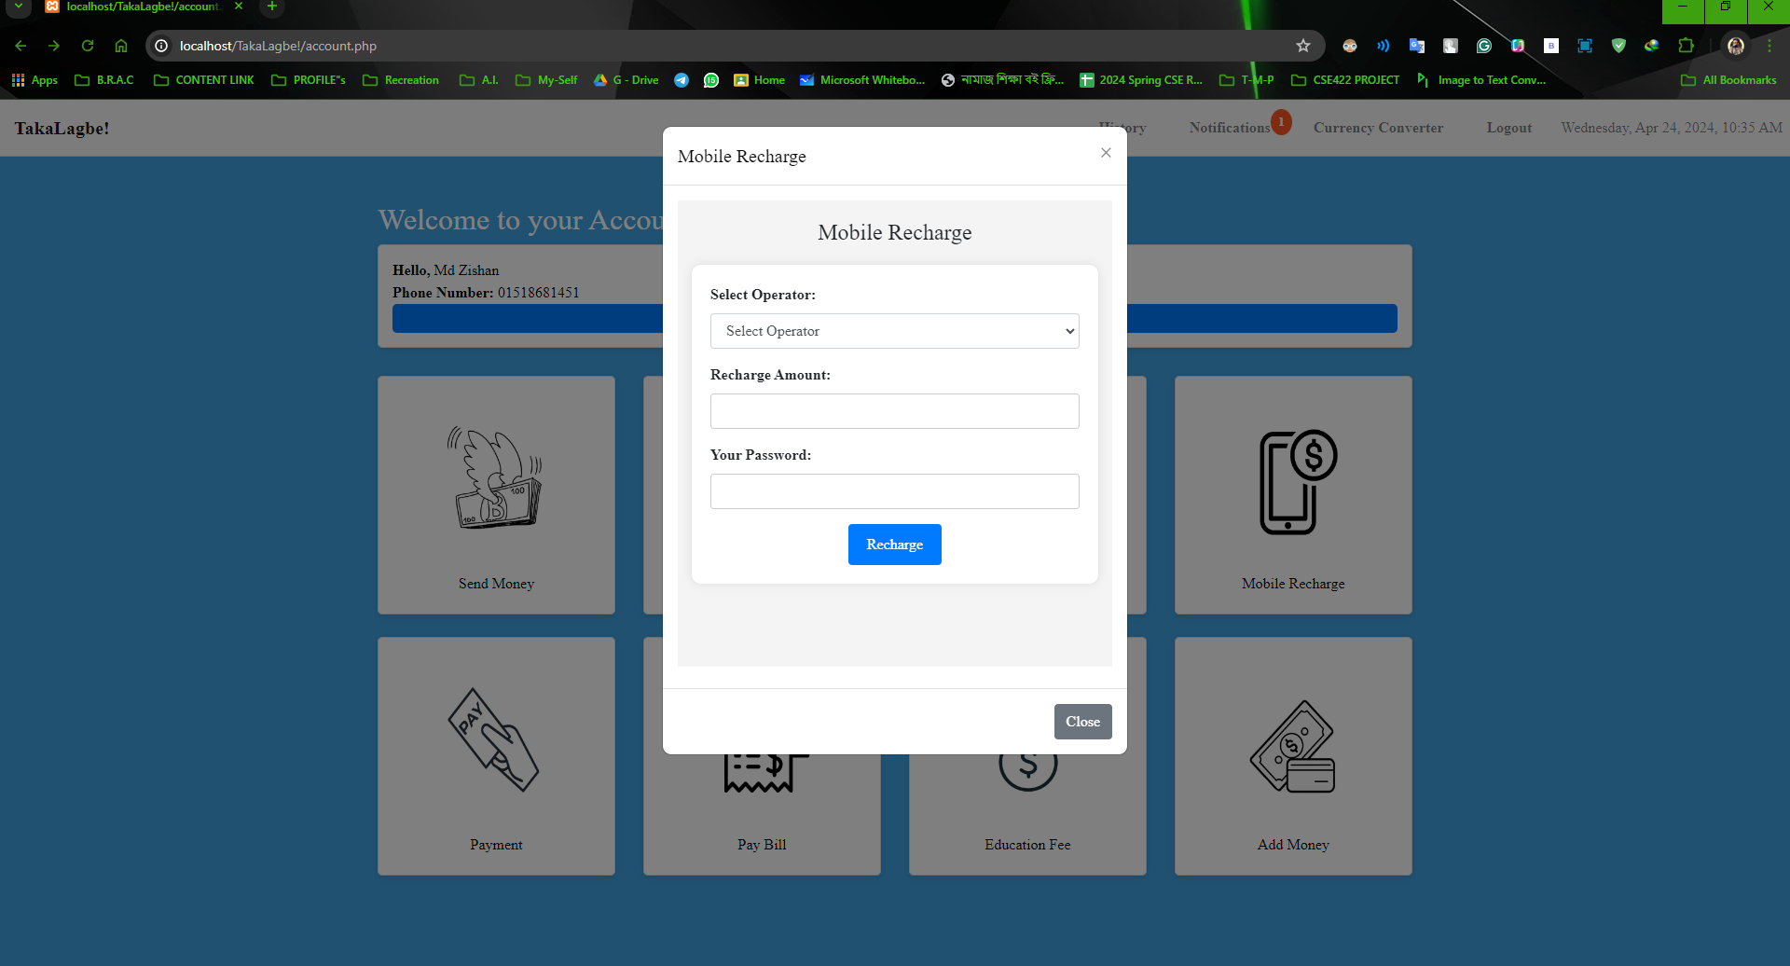

**Notification :**

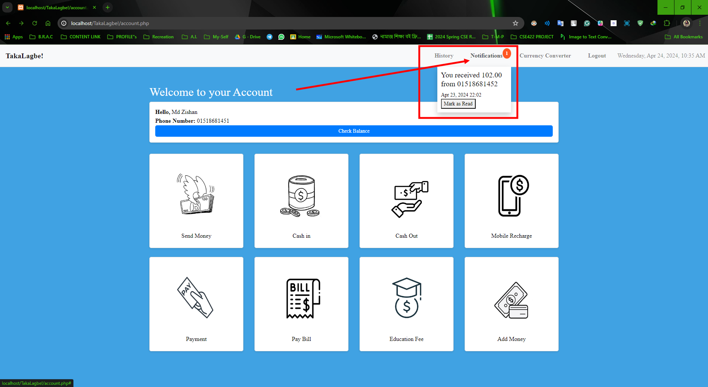

**Support :**

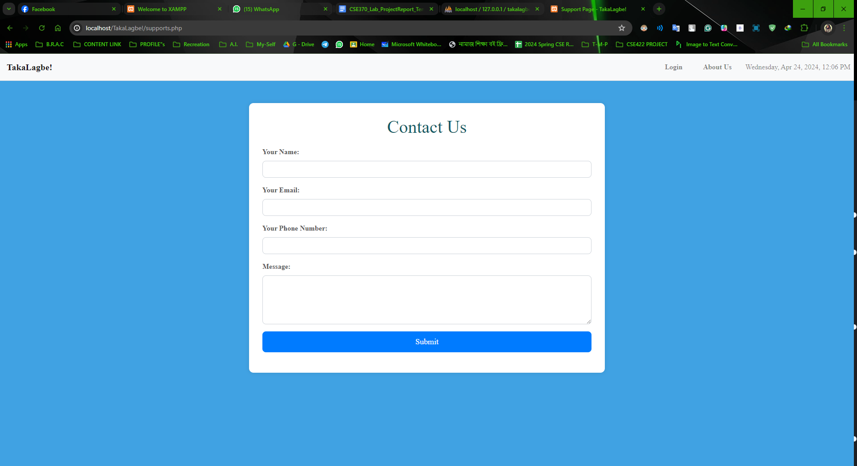

**Backend Development**

*Contribution of ID : 22301061, Name : FAIAZ ABRAR ZAMAN PRONOY*

*-> Login, Signup, Logout, Check Balance, Pay Bill, Education Fee, History, Add Money*

**Explanation :**

**Upon navigating to the URL https://localhost/TakaLagbe!/login.php, users encounter a login or signup interface. New users have the option to create an account, where uniqueness is ensured across National ID (NID), email, phone number, and User ID fields. The User ID is auto-incremented, while the mobile number serves as the primary key. Upon successful validation of all entered information, the website facilitates the creation of a new account and redirects users to the login page.**

**On the login page, users enter their phone number and password, which are then matched with the database. In case of mismatch, users are prompted to retry. Upon successful authentication, users are redirected to the account page.**

**Key functionalities of the website include :**

**1. **Logout:** Enables users to securely log out of their accounts.**

**2. **Check Balance:** Allows users to view their account balance.**

**3. **Pay Bill:** Facilitates bill payments through the website.**

**4. **Education Fee:** Offers a platform for users to pay educational fees.**

**5. **History:** Provides a record of transaction history.**

**6. **Add Money:** Enables users to deposit funds into their accounts.**

**These functionalities collectively enhance user experience and streamline financial management on the platform.**

Login:

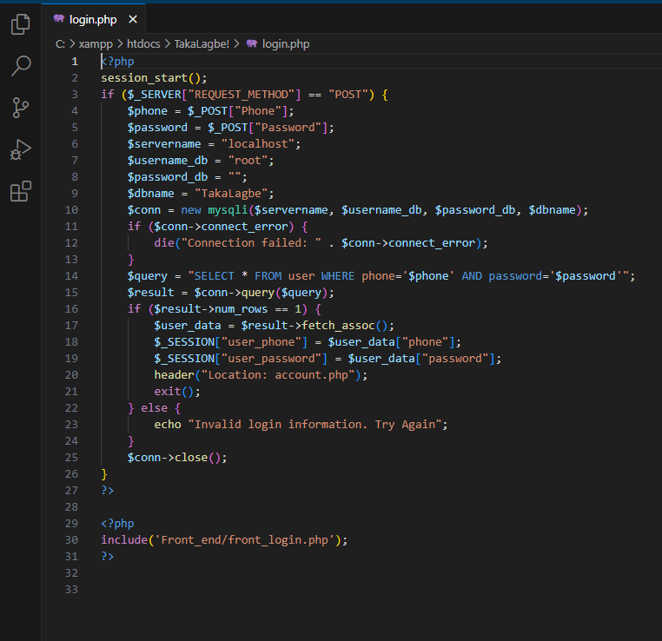

Signup:

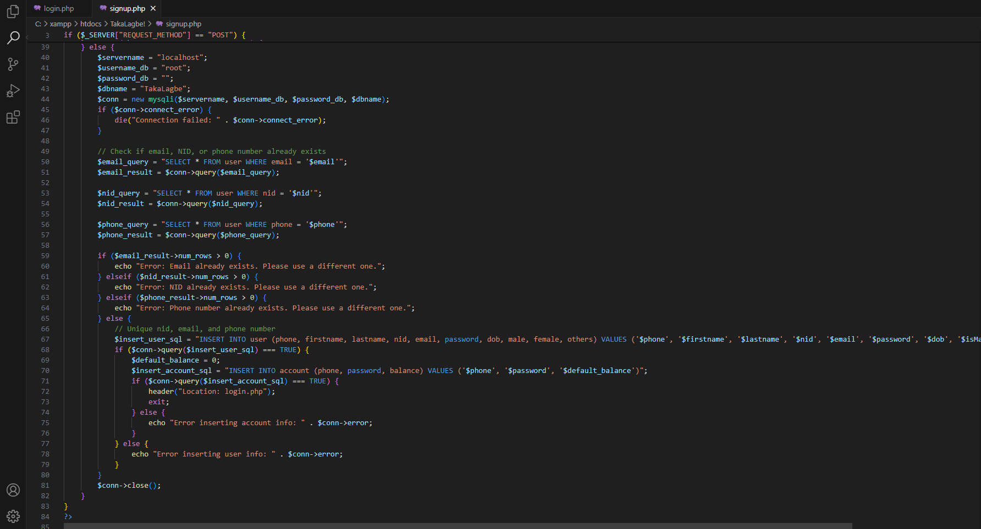

Logout:

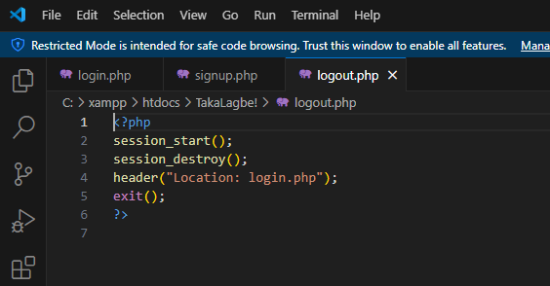

Check Balance:

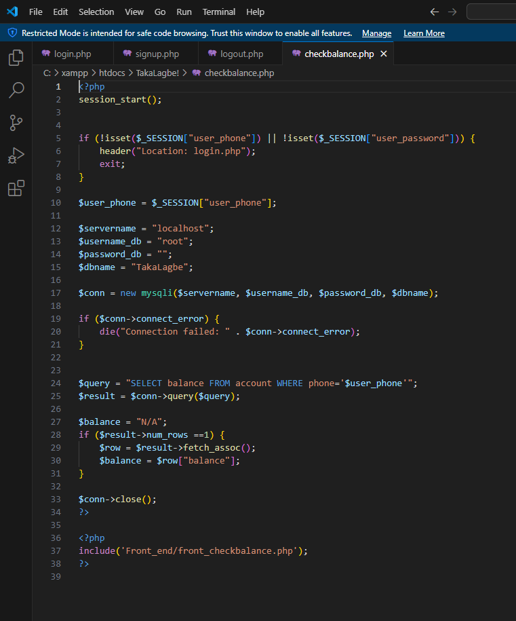

Pay Bill:

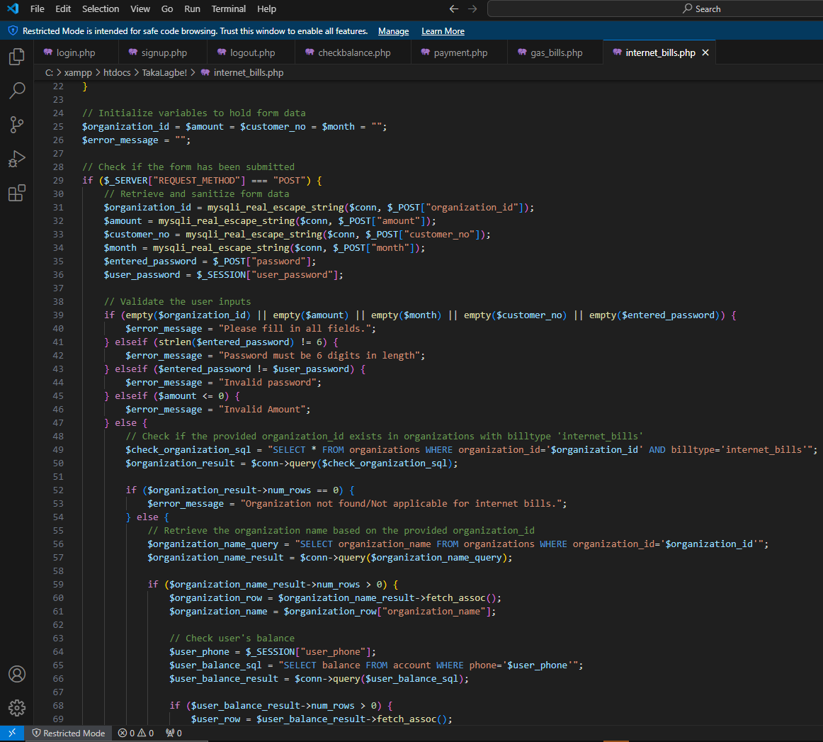

Education Fee:

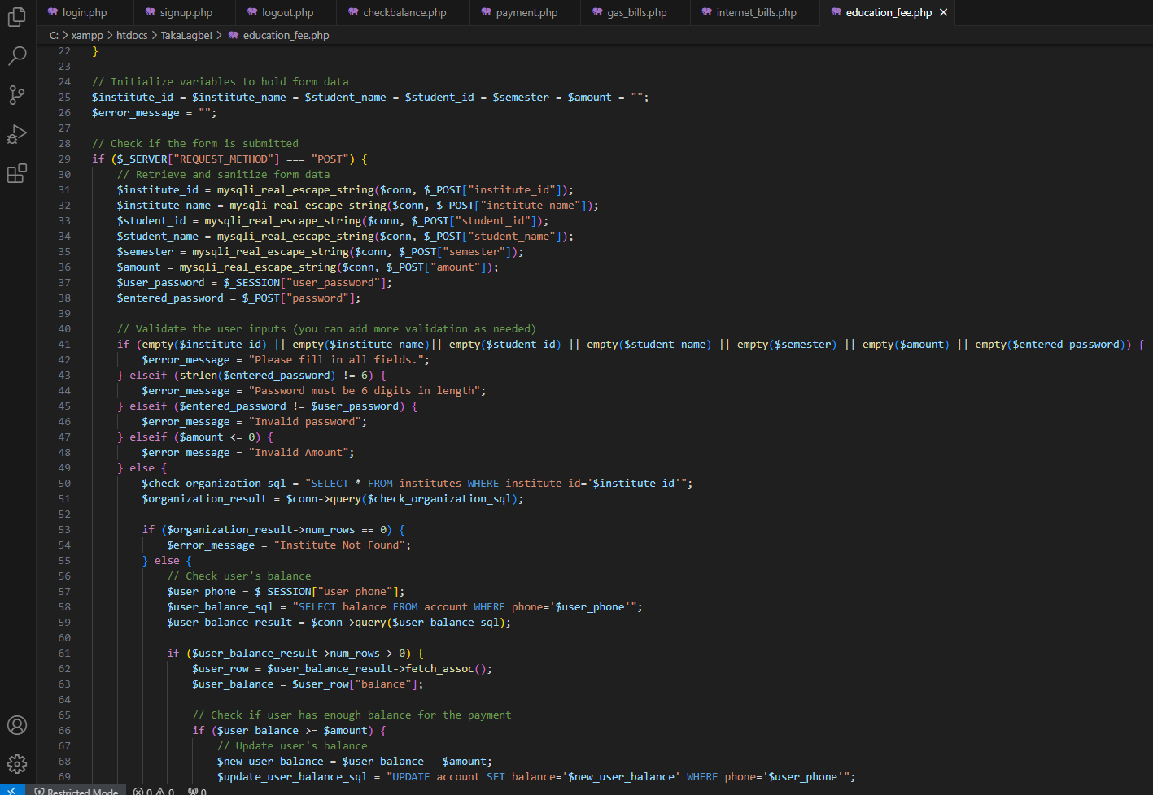

History:

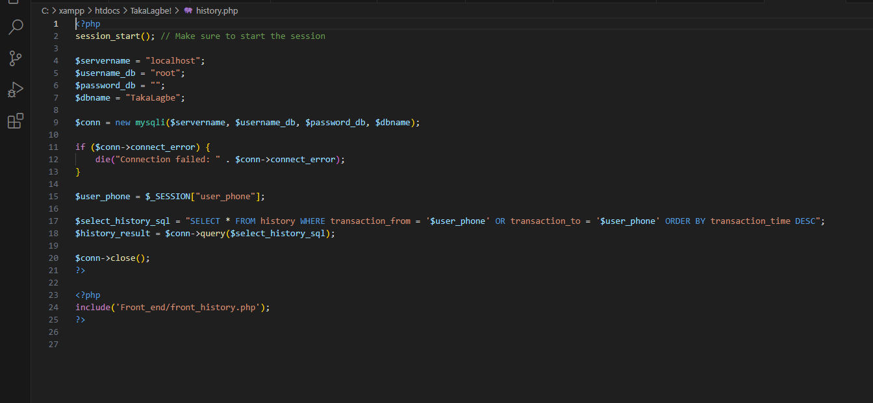

Add Money:

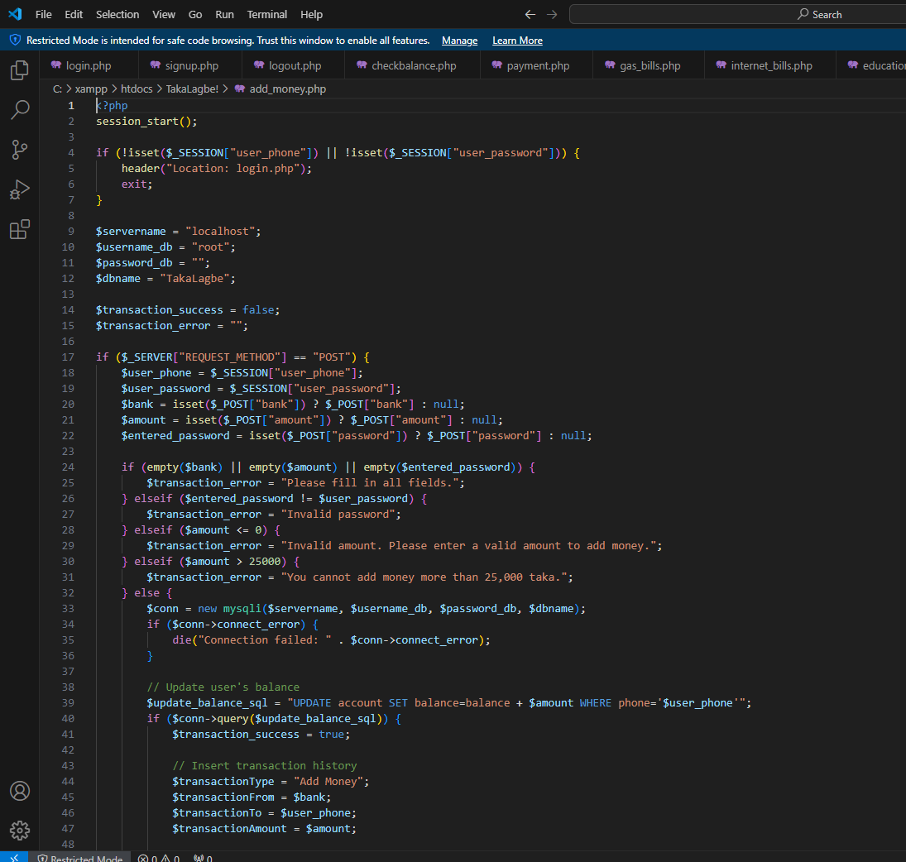

*Contribution of ID : 21301474 , Name : MD JAHIRUL ISLAM ZISHAN*

-> Reset Password, Send Money, Mobile Recharge, Notifications, Support

**Explanation :**

**1. **Support Page:\*\***

**- Purpose: Provides a platform for users to report complaints and seek assistance.**

**- Functionality: Users can submit messages detailing their issues or challenges.**

**- Benefit: Offers a direct communication channel with the administration for prompt issue resolution.**

**2. **Password Reset:\*\***

**- Purpose: Enhances account security and user convenience.**

**- Process:**

**- Validates matching National ID (NID) and mobile number.**

**- Allows users to initiate password changes securely.**

**- Importance of NID: Crucial for stringent account verification, ensuring account integrity.**

**3. **Send Money:\*\***

**- Purpose: Facilitates secure peer-to-peer transactions within the platform.**

**- Process:**

**- Users specify sender and recipient phone numbers, amount, and password.**

**- Transactions exceeding 25,000 undergo additional verification.**

**- Confirmation via tapping the "Send Money" button.**

**- Security: Ensures safe transfers while maintaining user control over funds.**

**4. **Mobile Recharge:\*\***

**- Purpose: Simplifies the process of mobile recharge for users.**

**- Steps:**

**- Operator selection, recipient phone number, and recharge amount input.**

**- Authentication via password.**

**- Instant processing of recharge upon confirmation.**

**- Convenience: Streamlines communication service top-ups with a user-friendly interface.**

**5. **Notification for Receiving Money:\*\***

**- Purpose: Keeps users informed of incoming transactions.**

**- Instant Alerts: Users receive real-time notifications upon receiving funds.**

**- Transparency: Enhances visibility into financial activities within the platform.**

**By breaking down each feature into distinct points, users can better grasp the functionality and benefits of each, leading to improved usability and understanding.**

**Reset Password:**

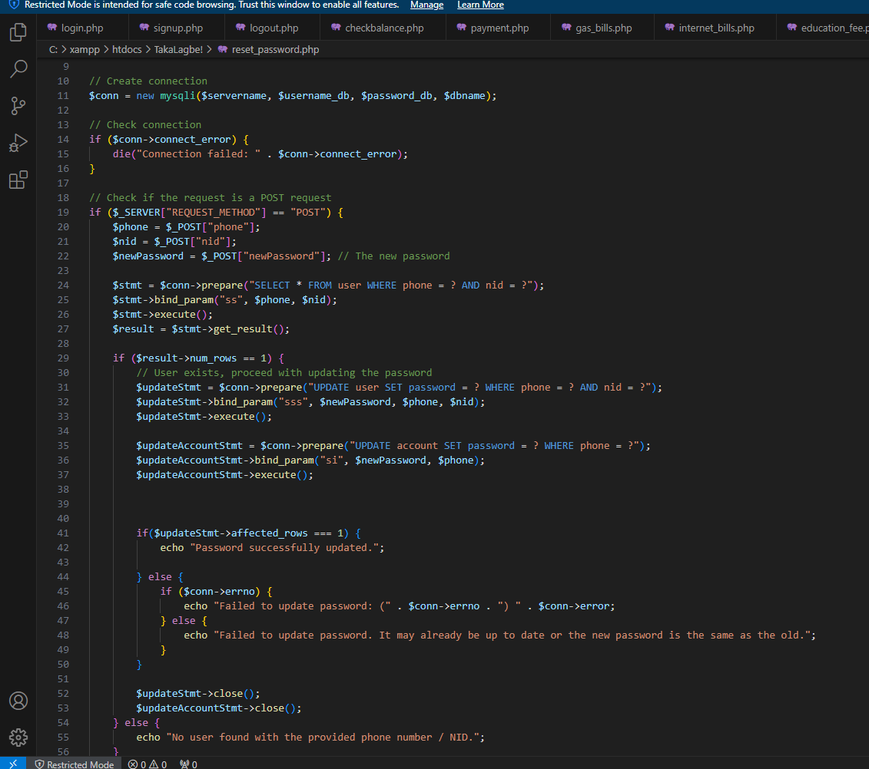

**Send Money:**

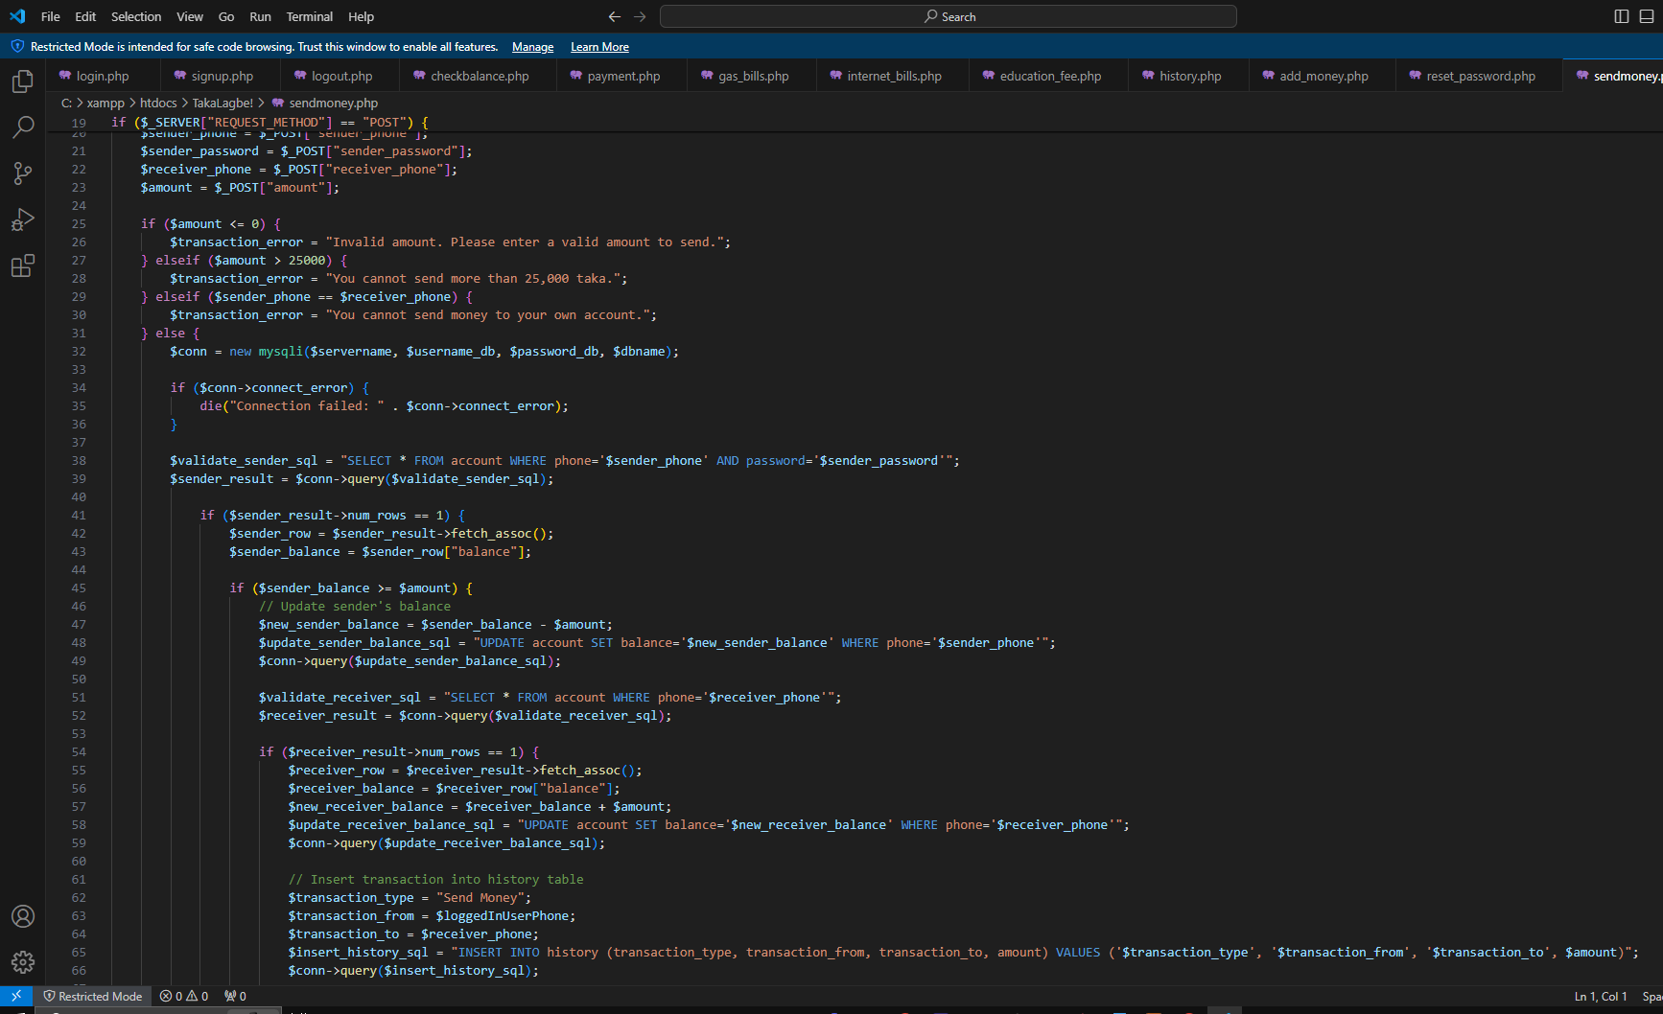

**Mobile Recharge:**

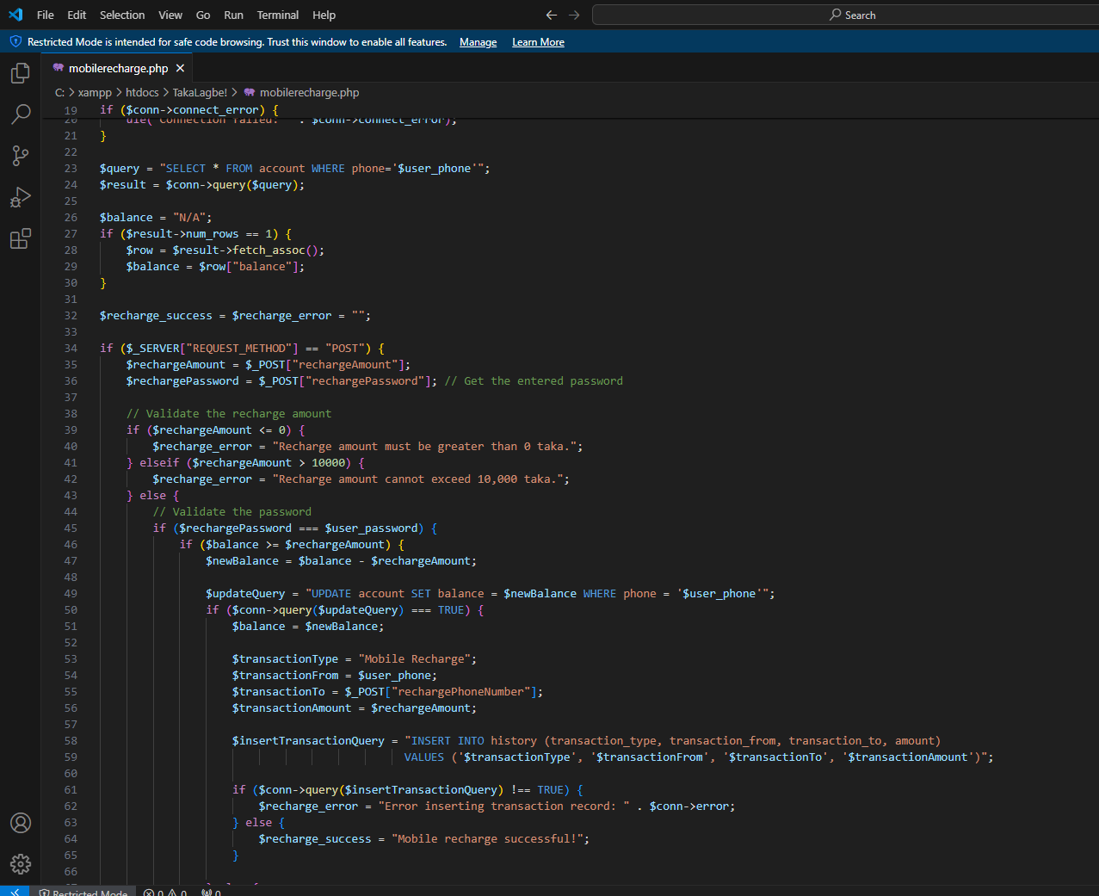

**Notifications:**

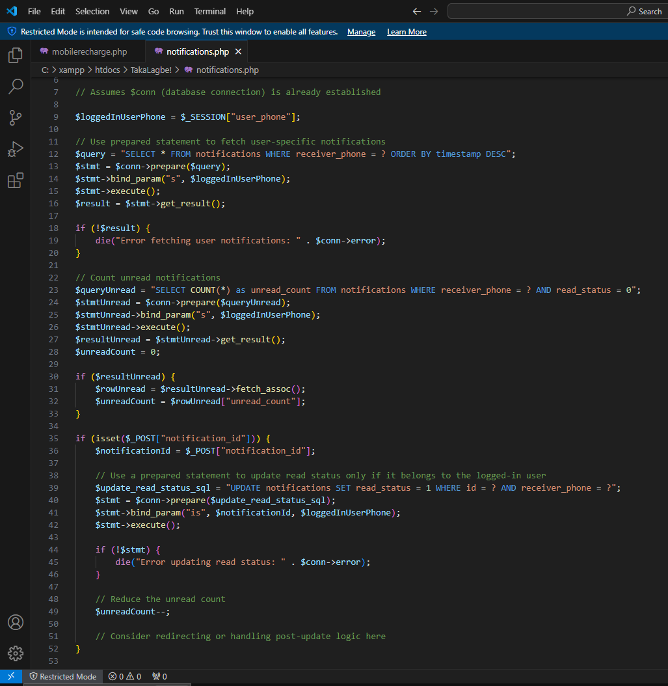

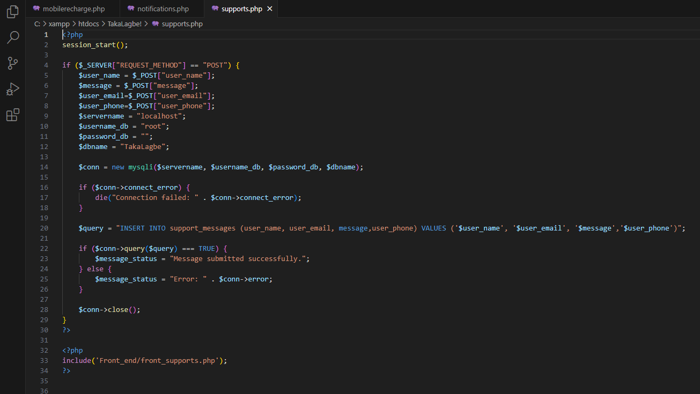

**Contribution of ID : 21301298, Name : Md. Shihab Sarar**

**->**Cash In, Cash Out From Agent

**Explanation :**

Key functionalities of the website include :

1. **Cash In:** Clicking the Cash In button deducts money from the agent's balance. Upon navigating to the URL <https://localhost/TakaLagbe!/cash_in.php> the user encounters a page where there will be an Agent page . Then the user will go to the Agent and enter the agent's Agent id , the number to add money and the amount.

2. **Cash Out:** Clicking the Cash In button Adds money from the agent's balance. Upon navigating to the URL [https://localhost/TakaLagbe!/cash_out.php](https://localhost/TakaLagbe!/cash_in.php) the user encounters a page where there will be an Agent page . Then the user will go to the Agent and enter the agent's Agent id , the number to cash out money and the amount.

Cash In :

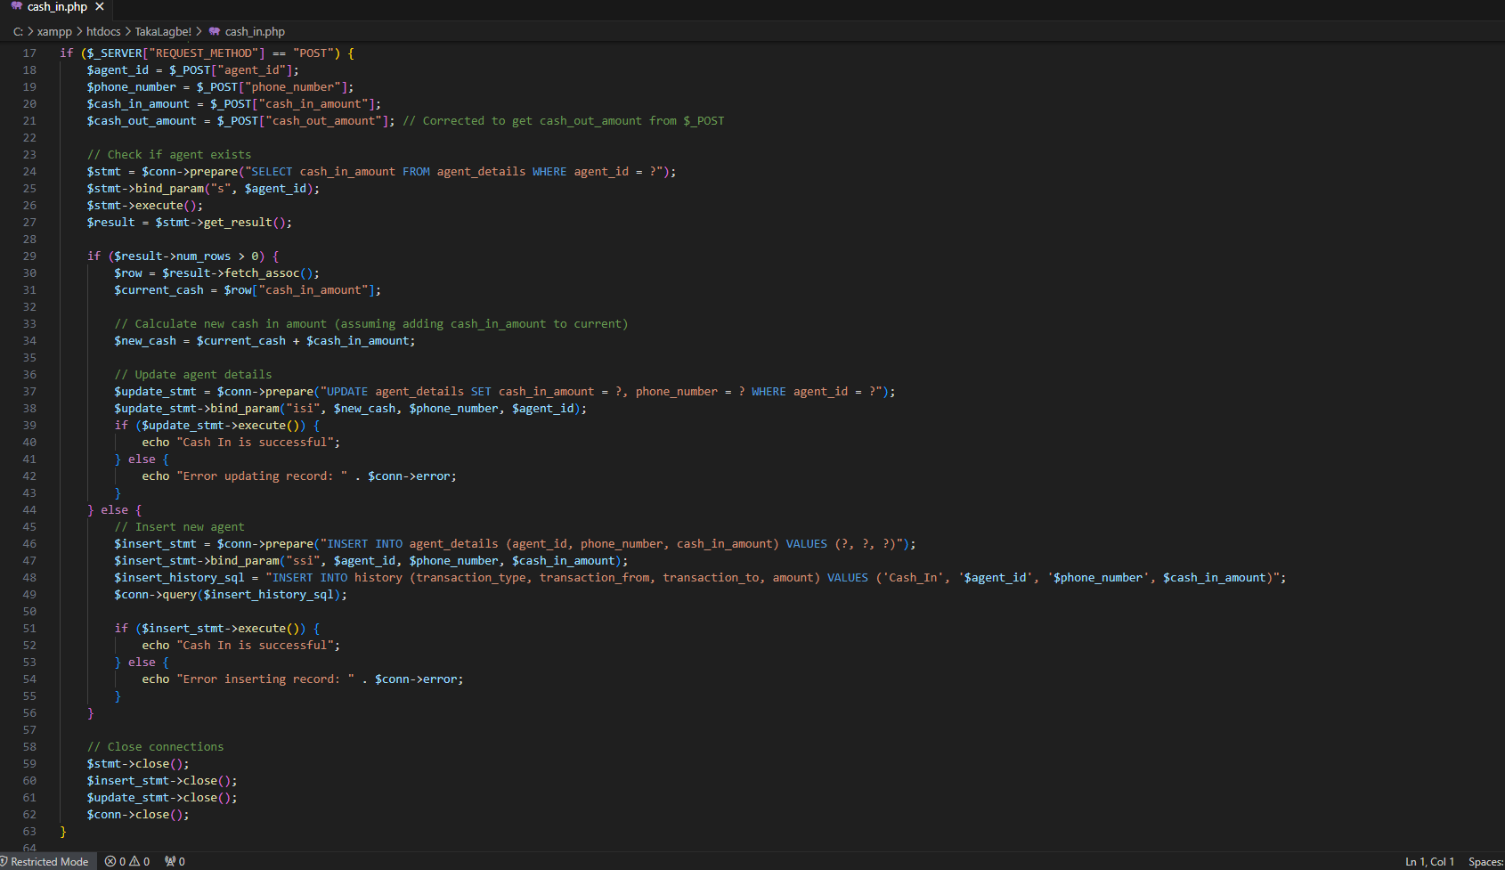

Cash Out :

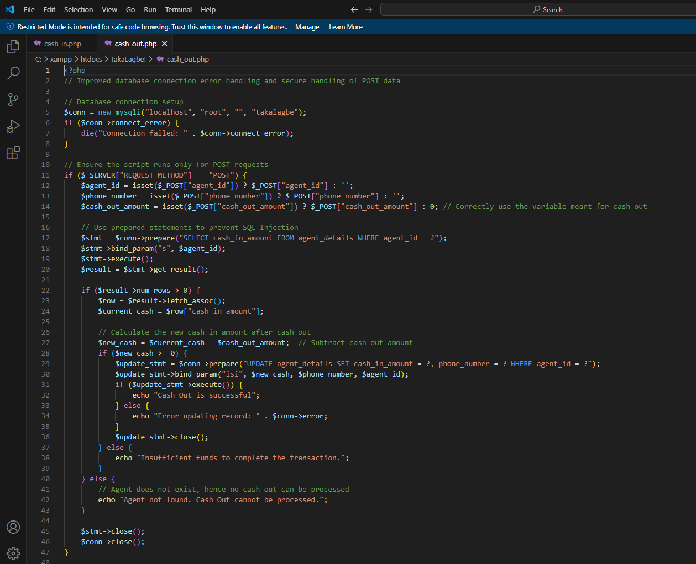

Contribution of ID: 21301581 , Name: Nafiz Ahmed Rhythm

-> Makes Payment,Admin(support, user, solved support,login, logout),Currency Converter

**Explanation :**

Our payment system offers a streamlined platform for users to securely make transactions while providing you, the administrator, with comprehensive control over every aspect of its operation. From managing user accounts to monitoring transactional activity, your admin dashboard empowers you to oversee the system's performance and ensure seamless functionality. With robust security measures in place and a focus on user experience, your system fosters trust and reliability, driving satisfaction for both customers and administrators alike.

Makes Payment:

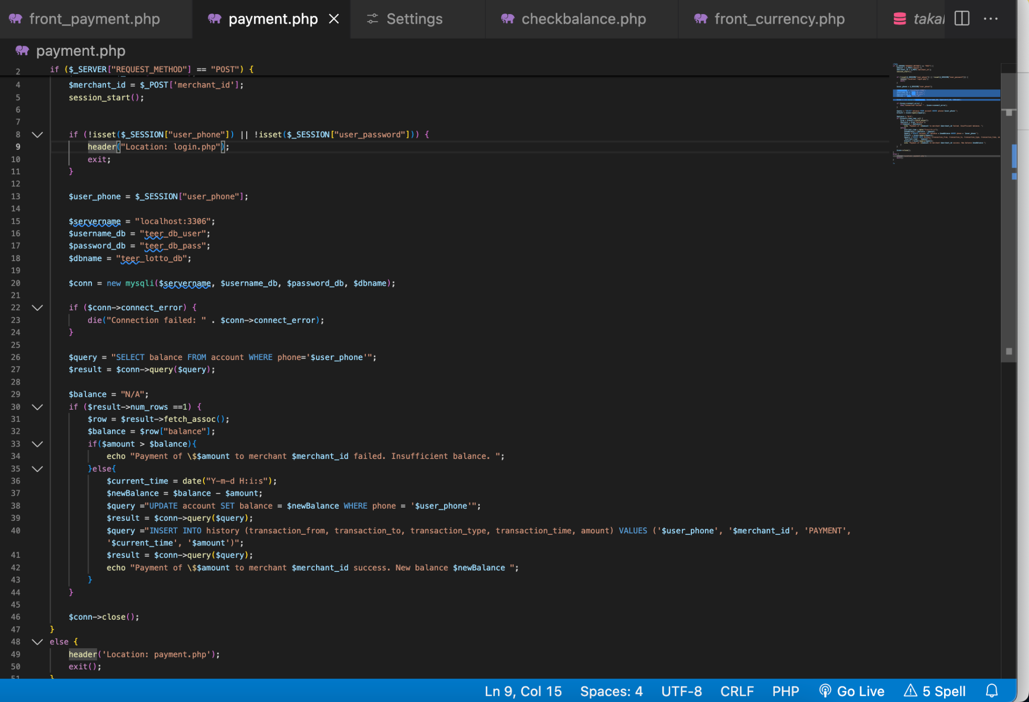

Currency Converter :

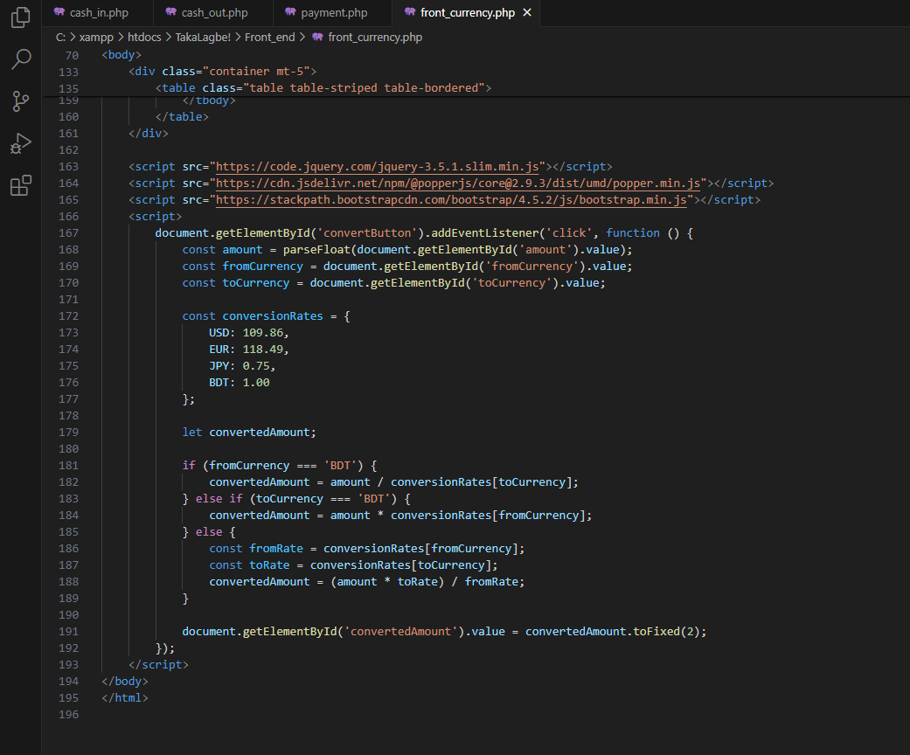

**Admin:**

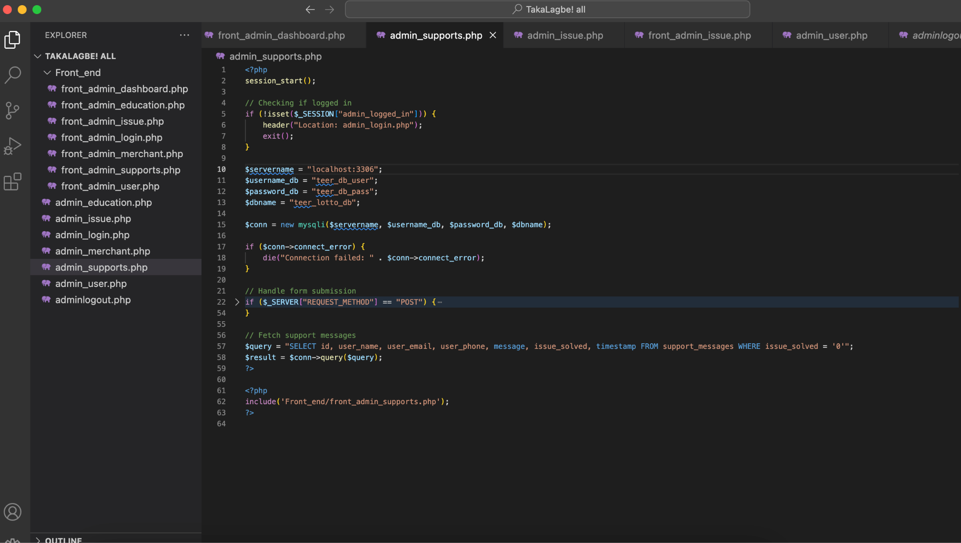

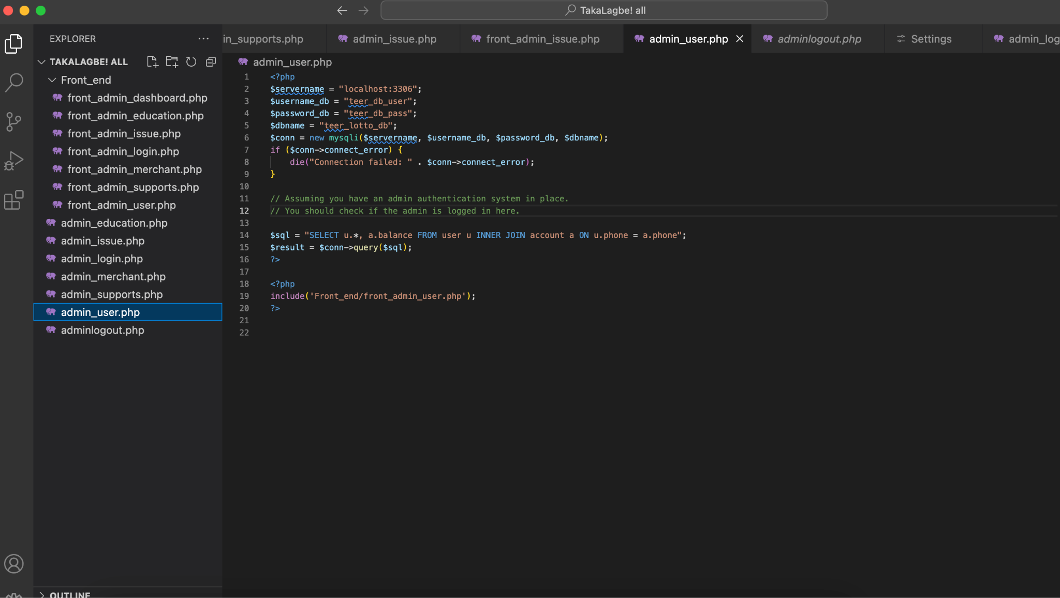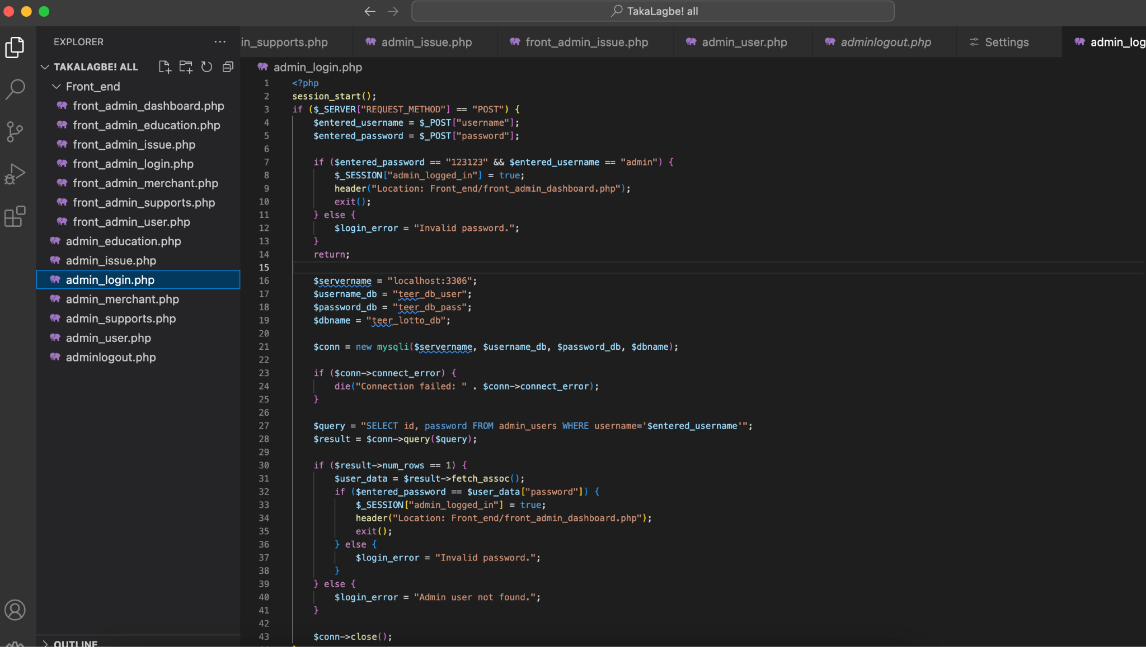

**Source Code Repository**

<https://drive.google.com/file/d/1whw1VVlMPj55gReoAQYTKvdz0tCcZCII/view?usp=sharing>

**Conclusion**

In summary, our project, "TakaLagbe," adeptly addresses the complexities inherent in modern financial transactions. By providing a user-friendly interface, ensuring efficient data management, delivering real-time transaction updates, and enforcing stringent security measures, we have developed a comprehensive solution that benefits both individual users and businesses. While this report outlines the scope and achievements of our project, the journey towards a fully operational system is ongoing. Our initiative sets the stage for future enhancements aimed at delivering seamless financial experiences and optimizing operational efficiency across various sectors. Moving forward, continuous collaboration and adaptability will be crucial. The insights gained from this project will be invaluable for future developments in financial technology. Ultimately, our efforts demonstrate how innovative technology can enhance efficiency and user satisfaction, contributing to the ever-evolving landscape of global financial services.

**References**

**1.** **Bootstrap:**

**Bootstrap. (n.d.). The most popular HTML, CSS, and JS library in the world. https://getbootstrap.com/**

**2.** **Stack Overflow:  
 Stack Overflow. (n.d.). Stack Overflow - Where Developers Learn, Share, & Build Careers. https://stackoverflow.com/**

**3.** **PHP.net:**

**PHP. (n.d.). PHP: Hypertext Preprocessor. https://www.php.net/**

**4.** **CSS-Tricks:**

**CSS-Tricks. (n.d.). CSS-Tricks. https://css-tricks.com/**

**5.** **Codecademy:**

**Codecademy. (n.d.). Learn to code - for free. https://www.codecademy.com/**

**6.** **FreeCodeCamp:**

**FreeCodeCamp. (n.d.). Learn to code with free online courses, programming projects, and interview preparation for developer jobs. https://www.freecodecamp.org/**

**7.** **CodeswithHarry Youtube channel**

**https://youtu.be/1SnPKhCdlsU?si=RKXFOymENNJ7_3yD**